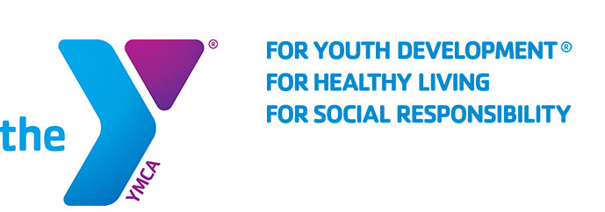

FOR IMMEDIATE RELEASE
JUNE 7, 2019

THE FAMILY YMCA OF THE DESERT ANNOUNCES RECORD BREAKING CAMP OAKES ATTENDANCE AND SCHOLARSHIPS

PALM DESERT, CA- The Family YMCA of the Desert is proud to announce that this year, a record number of children will be attending Camp Oakes in Big Bear, CA. 340 children, ages 8-15, will depart on Saturday, June 15th, 2019 from the Palm Desert YMCA and will return from their camping adventure on Saturday, June 22nd, 2019.

Through its Send A Kid to Camp fundraiser, The Family YMCA of the Desert will provide over 100 full and partial scholarships to families who cannot afford the $540 total cost of camp.

During their stay at Camp Oakes, campers stay in 3-walled cabins and take part in daily activities such as canoeing, hiking, swimming, riding horses, and climbing. Through these activities and in conjunction with the positive reinforcement offered by their counselors, campers will gain confidence and learn responsibility, cooperation, leadership and respect.

Other activities include: archery, canoeing, fishing, hiking, campfires, swimming, zipline, arts & crafts, climbing wall, ropes course, team building, sling shots, leadership program and more.

Learn more about Camp Oakes at : http://www.ymcaofthedesert.org/camp-oakes/

For any other questions, call the Y at 760-341-YMCA

About The Family YMCA of the Desert
The Family YMCA of the Desert is the largest provider of licensed child care in the Coachella Valley, with facilities from Palm Springs to Mecca. It serves over 3,800 local kids and families daily at its forty sites--providing a variety of programs, camps, and other special events in benefit of the local children in the Coachella Valley.

