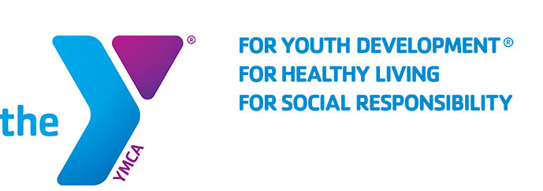

FOR IMMEDIATE RELEASE
SEPTEMBER XX, 2019

THE FAMILY YMCA OF THE DESERT ANNOUNCES SIXTH ANNUAL Y BE FIT PALM DESERT CHALLENGE

PALM DESERT, CA -- The Family YMCA of the Desert, in partnership with the City of Palm Desert, will host its sixth annual health and wellness fair, the “Y Be Fit Palm Desert Challenge”. The event will kick off at 7:00 AM on October 6th, 2019.

Participants can take part in the 5K run/walk, sponsored by Prime Time Int’l or test their endurance with the Reverse Triathlon, sponsored by Burrtec, the reverse triathlon is composed of a 5K run/walk, a 10 mile bike ride and a 300 meter swim. Athletes can take part in the challenge individually or as part of a three person team. All team members will receive an event t-shirt and a finisher medal. In addition, families can take part in the 2K Color Run, sponsored by First Bank. With four color stations across the course and 600 pounds of color this event will be a vibrant, technicolor spectacle for the whole family to enjoy.

The Family YMCA of the Desert is proud to present Karen Creasey, of Karen Creasey Health and Wellness Motivation as the Chairman of the 2019 Y Be Fit Palm Desert Challenge. Creasy is a health and wellness motivational speaker who helps empower people and transform their lives.

The Mayor’s Cup trophy will be awarded to the top male and female athlete of the reverse triathlon. Their names will be engraved on the trophy and be displayed in both the Palm Desert City Hall and the Family YMCA throughout the year. In addition, the Fitness Club Challenge gives two fitness clubs the opportunity to win an award. A special plaque will be given to the fitness club that has the most people registered in the 5K and triathlon. The second special plaque will be given to the fitness club with the fastest relay team in the triathlon out of all other competing fitness clubs.

The Y Be Fit Palm Desert Challenge will feature booths, music and pool play. Registration and more information can be found at: https://www.ymcaofthedesert.org/y-be-fit/ or (760)341-9622

About the Family YMCA of the Desert
The Family YMCA of the Desert is the largest provider of licensed child care in the Coachella Valley, with facilities from Palm Springs to Mecca. We serve over 3,500 local kids and families each day at our thirty-seven sites. We also provide a variety of programs, camps, and other events and activities for members of our community. The primary focus of the Y is to reinforce caring, honesty, respect, and responsibility while also helping kids to develop social skills, confidence, leadership, and fitness.

