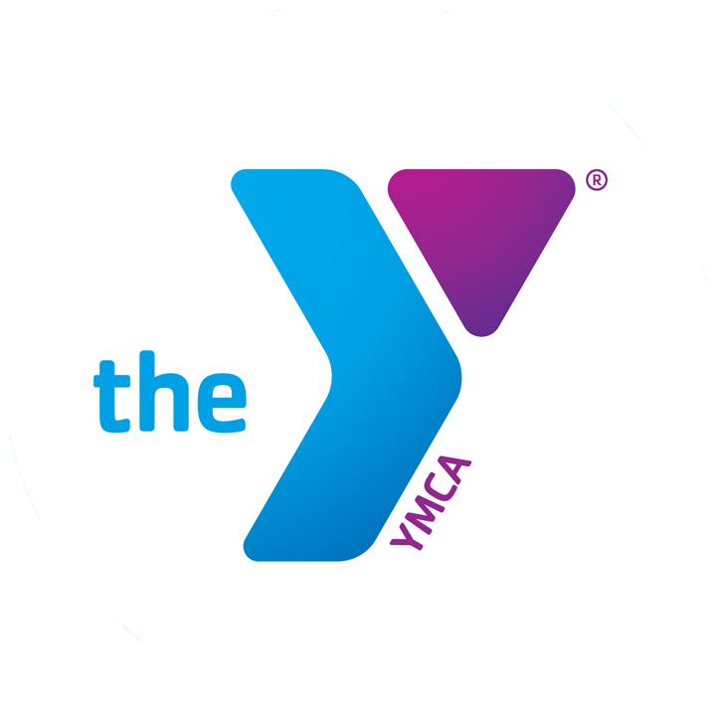
FOR IMMEDIATE RELEASE
APRIL 12, 2019

THE FAMILY YMCA OF THE DESERT ANNOUNCES ANNUAL EASTER EGG HUNT AND HEALTHY KIDS DAY

PALM DESERT, CA-- The Family YMCA of the Desert will host its annual Easter Egg Hunt and Healthy Kids Day on Saturday, April 20th, 2019. Festivities will kick off at 10:00 AM at the Palm Desert YMCA located at 43-930 San Pablo Ave. The event is free and open to all ages.

There will be plenty of eggs to go around for kids and families, as well as tons of prizes and giveaways.Participants are invited to stay after the Egg Hunt for “Healthy Kids Day” at the park.

For more information, call the Y at: (760)341-9622

About the Family YMCA of the Desert
The Family YMCA of the Desert is the largest provider of licensed child care in the Coachella Valley, with facilities from Palm Springs to Mecca. We serve over 3,800 local kids and families each day at our forty sites. We also provide a variety of programs, summer camps, and other events and activities for members of our community. The primary focus of the Y is to reinforce caring, honesty, respect, and responsibility while also helping kids to develop social skills, confidence, leadership, and fitness.

